**CIAED PAPER: MODEL AND GUIDELINES FOR AUTHORS**

*CIAED PAPER: TEMPLATE AND GUIDELINES FOR AUTHORS*

Name of Author 1 - Institution of Author 1

Name of Author 2 - Institution of Author 2

Name of the Author n - Author's Institution n

<email author 1>, <email author 2>, <email author n>

**Abstract**. This text presents the formatting rules that must be followed by papers submitted to CIAED 2025. This paper also strictly follows these rules and can be used as a *template*. Therefore, following these rules, this abstract has between 50 and 100 words and presents three to five keywords written with the initials in lowercase letters (except proper nouns, acronyms, and scientific names), separated by semicolons, and ending with periods.

**Keywords**: CIAED 2025; ABED; distance education; hybrid education; educational technology.

**1 Introduction**

This text[1] can be used as a formatting model for preparing papers to be submitted to the 30th CIAED - ABED International Congress of Distance Education, which must be written in English. The content of this paper, which presents the rules and formatting recommendations, should be considered as something other than an example of scientific writing. Its formatting, however, follows exactly the rules established here.

This document is available in two versions: PDF and *Word*. When you start preparing your paper, it is recommended that you download the most recent version of this model paper, especially when preparing the final version of the paper, after its approval.

**Attention**: Remember to put the title of your paper up there, include the authors’ names and their institutions just below the title, and edit the headings appropriately with author names (even page) and the paper’s title (odd page), as indicated.

**2 Paper Categories and Formats**

In previous versions of the CIAED, each paper submitted for presentation at the Congress should be identified as belonging to one of the eight categories listed in Chart 1. This is no longer necessary. We have kept this information here only to illustrate the use of a Table.

Table 1 - Categories of papers that were used for the 28th CIAED; these categories will not be used in the 30th CIAED and are presented here only as an illustration of the use of the Table.

|  |  |  |  |  |  |
| --- | --- | --- | --- | --- | --- |
| **Category** | | **Description** | **C** | **R** | **P** |
| IC | Scientific research | Conclusive results (full papers) or partial results (short papers or postes) of unpublished scientific research. | x | x | x |
| EC | Case Study | Based on real data and an academic-scientific foundation, the discussion is a relevant case for distance education. Full papers should highlight the study's contributions. | x | x | x |
| RL | Literature Review | Unpublished results on state-of-the-art conceptual mapping and answers to certain scientific questions through secondary research in bibliographic databases; for full papers, it is recommended that systematic reviews (SR) of the literature be carried out and the research methodology/protocol of the SR be presented. | x | x | x |
| PA | Project in Progress | Research, development, or other projects related to distance education that have not yet been closed can be discussed with the academic-scientific community participating in Congress. In this way, authors will be able to receive important feedback, which will contribute to their projects and the preparation of future papers, and the community will be able to update and follow recent research and innovations firsthand. |  | x | x |
| NO | Innovative Experience Report | Presentation and discussion of didactic-pedagogical and management experience |  | x | x |
| C | Communication | Presentation, analysis, and discussion of products, services, tools, technologies, content, and other innovative solutions for distance education. |  | x | x |
| P | Proposal | Innovative ideas and proposals on any subject related to distance education should be adequately problematized, justified, and substantiated, and they should be presented and discussed with the community participating in Congress. |  | x | x |
| And | Essay | The academic, unpublished, and current paper, of opinion or knowledge organizer, discussing a topic relevant to distance education |  | x |  |

Source: CIAED 2023 call (sic) (Abed, 2023), adapted and placed in the form of a table by the authors

Papers can be submitted in three formats, all following this same formatting model. The following sections introduce each of the three formats.

**2.1 Full Paper**

Complete papers containing up to twelve pages, including bibliographic references. They must present unpublished contributions with conclusive and significant results. They will be presented orally in thematic technical sessions during the Congress if approved.

**2.2 Short Paper**

Short papers can be up to five pages and include bibliographic references. They can present essays (opinion papers), ongoing projects, partial results of research and studies, innovative proposals, or communications (on innovative technologies, tools, methodologies, and/or content). They will be presented orally in thematic technical sessions during the Congress if approved.

**2.3 Poster**

Posters can be up to two pages and follow the same formatting rules as full and short papers. They can present ongoing projects, partial results of studies and research, and innovative proposals or communications (on innovative technologies, tools, methodologies, and content). If approved, they will be presented in specific sessions in their own space on the exhibition grounds, open to all attendees.

In addition to the paper itself, the authors will be responsible for making the (physical) presentation posters, also known as *banners*, according to the specific format that will be informed to them when the work is announced and for taking them to the event. At least one of the authors of each work must remain next to the respective presentation poster during the session.

The "presentation poster" should not be confused with the "poster " submitted and approved. The "presentation poster" will be prepared later as a poster and used only during the respective session in the event space. In contrast, the "poster," as submitted and approved, will be a scientific paper published in the Annals of the Congress.

**3 Formatting Rules**

The margins should be 2 cm—A4 sheet. The font type of the body text should be Arial, size 11, except to use size 10 in the following situations: long quotations, footnotes, page numbering, captions, and sources of figures and tables. Single spacing. Title of left-aligned sections. The main and secondary headings should be separated from the text by a blank line (a single space). There should be no indentation at the beginning of each paragraph and a single space between each paragraph (ENTER).

The paper must contain pre-textual parts (title, authorship, abstract, keywords), textual parts (introduction, development, conclusion, or final considerations), and post-textual parts (bibliographic references). Next, this template presents each of the textual and post-textual elements.

**3.1 Title**

The title is a mandatory element. It must be centered in bold capital letters, in Arial font, size 14, English. The subtitle, if any, should be separated by a colon ( : ).

Suppose the paper has four or more authors, six being the maximum number allowed. In that case, separating them by semicolons instead of writing one per line is recommended when listing them below the title. Chart 2 exemplifies this situation.

Chart 2 - Examples of the arrangement of the authors' names according to the number of authors

|  |  |
| --- | --- |
| up to three authors | four or more authors |
| PAPER TITLE  Romero Tori - USP  João Mattar - PUC SP  Ketia Silva - EGN | PAPER TITLE  Romero Tori - USP; João Mattar - PUC SP; Ketia Silva - EGN; Fulano de Tal - Fuban |

Source: authors

Avoid very long papers and section titles. When creating these titles, try highlighting the key concepts and being as clear as possible and interesting to the reader. Leave the details to the abstract or the corresponding section. If the paper’s name must be long, abbreviate it in the header so it only takes up one line.

**3.2 Authorship**

The author's name or authors must be just below the title, centered, directly (Name and Surname), followed by the institution (acronym) and e-mail address. All information omitted when submitting the papers, including any acknowledgments to the people and institutions that contributed in some way to the work (non-authors) and recognition of sponsorships, support, funding agencies, and others, will only be included in the final version of the paper, after approval, in preparation for publication in the Proceedings of the Congress.

**3.3 Abstract and Keywords**

The abstract must be written in English and contain up to 100 words, briefly informing the objectives of the paper, the methodology(s) used, the results, and the final considerations. Keywords should come just below the respective abstracts, separated by semicolons (;) and ending with a period (.), between three and five terms.

**3.4 First Page**

The first page has the title, names, information about authors (a maximum of six authors per paper), abstract and keywords, *and* information that cannot exceed the first page. Attention is recommended because the abstract will have less space if the title is very large and there are many authors.

However, if space remains on the home page, the first section can already be started on that same page (unless the available space is only sufficient to include the section title). In this case, the section should start on the next page. This same care should be taken on all pages so that none ends with a section or subsection title.

**3.5 Text**

The margins must be Left and Top 3 cm and Right and Bottom 2 cm—A4 sheet. The font type should be Arial, size 11, except using size 10 in long quotations, footnotes, page numbering, captions, and sources of figures and tables. Single spacing throughout the paper. Title of left-aligned sections. The main and secondary headings should be separated from the text by a blank line (a single space). There should be no indentation at the beginning of paragraphs.

Use italics for foreign words and quotation marks to refer to the term, such as when saying that more than one word was used in the search term "distance education" in the search for distance education.

Generally, it is recommended that numbers up to ten be written in full, except in cases where the numeral in the form of digits is mandatory, as in a formula, for example, or clarity. Quantitative data from small samples (five or fewer) should not be presented as a percentage. In these cases, placing the absolute numerical values directly in tables and graphs is recommended.

**3.6 Acknowledgments**

Acknowledgments (if any) should be inserted at the end of the text, before the References section, and without numbering, which should be the last section of the paper. At the end of this paper, check examples of these two sections.

**3.7 About the Sections and Subsections**

Sections and subsections must be numbered with Arabic numerals at all levels (1, 1.1, 2, 2.1, etc.). The paper should have, at most, five levels of sections. The titles of the sections and subsections must be capitalized with the first letters of the words, except for conjunctions and prepositions.

Section titles should have the following formatting:

the first level in size 14 and bold;

the second level in size 12 and bold;

the third level in size 11 and bold;

the fourth level in font size 11, italics and bold;

fifth level in size 11 and italics (no bold).

**3.7.1 Example of Third-Level Section**

This section was inserted only to exemplify the formatting of a third-level section.

***3.7.1.1 Example of Fourth Level Section***

This section was inserted only to exemplify the formatting of a fourth-level section.

***3.7.1.1.1 Example of Fifth Level Section***

This section was inserted only to exemplify the formatting of a fifth-level section.

The paper should have, at most, five levels of sections.

**4. Other elements**

**4.1 Tables**

Tables should be used to present qualitative and quantitative data, such as texts, figures, and numbers. To create a table directly in the text, use the editor's table feature or elaborate it in another tool and insert it as an image.

It should be noted that the tables must be cited in the text and inserted as close as possible to the passage to which they refer. Not to be used "below," "above," "next," "beside," or another form of reference other than the frame number.

Table 1 is presented as an example of these formatting rules.

Table 1 - ANOVA results for repeated measures for the comparison of variables in the performance measures of the subtests.

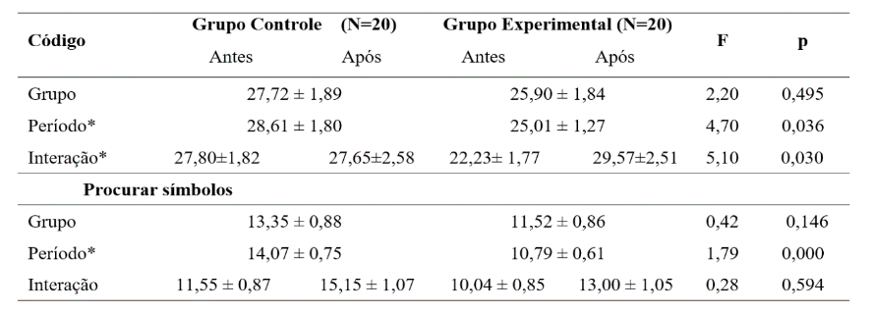

Source: Ramos and Mattar (2020).

**4.2 Figures**

All figures must have their identification (caption) at the top, in 10-centered font, and numbered according to the order in which they appear in the text. The source must be indicated at the bottom, in size ten, and adjusted to the left. It should be noted that figures must be cited in the text and inserted as close as possible to the passage to which they refer. It should not be used "below," "above," "next," "beside," or any other form of reference other than the figure number. An example can be seen in Figure 1, which presents the *banner* of the 29th CIAED that is displayed on the event's online page (Abed, 2024b).

Figures are graphs, images, diagrams, illustrations, or other graphic representations. Attention should be paid to the quality of the figures so that they do not become blurry, flawed, or illegible.

Figure 1 - *Banner* of the 29th CIAED - ABED International Congress of Distance Education

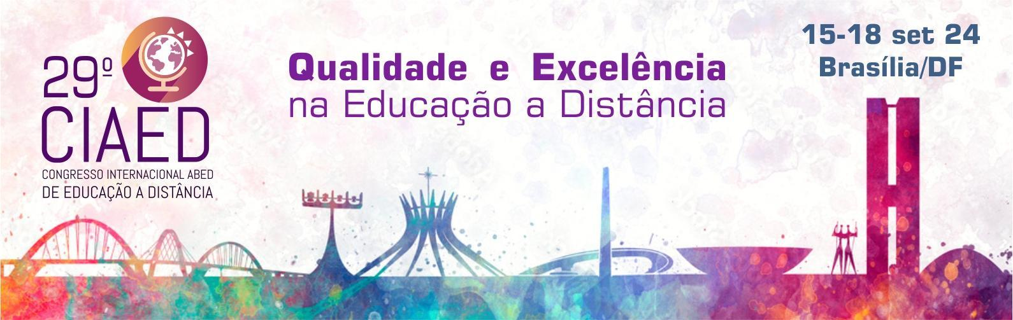

Source: Abed (2024b)

**5 Citations and references**

The quotations correspond to the transcription of another author in the text. It can be a full transcription (direct quote) or paraphrase (indirect quote). In some cases, when it is not possible to have direct access to the original text, a citation is made through the work of another author who used the original text.

Direct in-text quotations of up to three lines should be enclosed in double quotation marks. Single quotation marks are for quotations within the quotation.

Quotations with more than three lines must be highlighted with an indentation of 4 cm from the left margin, without quotation marks, and in a smaller font than the one used in the text.

If it is necessary to emphasize excerpts from the citation, they should be highlighted and indicate this change with the expression emphasis ours or emphasis added.

All cited sources must have complete references in ABNT format and be included in the references section.

Example of a direct quotation with up to three lines (embedded in the text):

According to Serra, Knuppel, and Horst (2021, p. 38), these professionals help teachers "to think about the planning of courses, disciplines, learning platforms, learning paths for students, among other forms of interaction with technologies in educational processes."

Direct quotation with more than three lines (highlighted in the text)

Thus, we are moving towards the all-hybrid. In this sense, the design and good practices of blended learning have risen to the level of art, involving knowledge of methodologies and technologies, among others, with professionals capable of properly planning this teaching modality increasingly valued and sought after in the education market. In some contexts and about some contents, it is more appropriate to learn at a distance and, in others, in person. On the one hand, *online activities* make it possible, for example, for teaching to be personalized in a way that would be impossible in the classroom, increasing **flexibility and convenience for students,** even allowing them to combine work with studies more adequately; on the other hand, part of the power of synchronous socialization in the classroom is lost at a distance. (Mattar, 2017, p. 27, emphasis added).

Example of indirect citation with the call embedded in the text:

According to Tori (2022), the metaverse can be a good alternative to videoconferences, as it can increase the perception of presence and provide more interactivity and involvement.

Example of indirect quotation (with the call separate from the text):

The rapid advance of digital technologies has enabled a new condition for the knowledge society, which, from the 1990s onwards, has been surrounded by the construction, production, processing, and use of knowledge. (Silva & Behar, 2022).

Example of citation of quotation (apud):

Neither new pedagogies for higher education nor the recognition and valorization of the pedagogical concepts that are already in force there, even if encapsulated, are defended; at the same time, the integration of new terms within the very concept of (university) pedagogy is defended, such as the concept of employability (Walker, 2021 apud D2L, 2021).

**5.1 Plagiarism, Self-Plagiarism, and Omissions of Credits**

Correct citation of the sources consulted is essential for the work’s credibility. By presenting different points of view of authoritative authors concerning the theme and attributing credit correctly, the author reveals in-depth research about the theoretical bases.

Thus, when transcriptions or copies of texts by another author (whether partial or full) are made without proper citation or reference, plagiarism is configured, and the author himself, self-plagiarism, which is an infraction with criminal implications according to Brazilian Law 9.610/98. Thus, citing and referencing the sources consulted, even those of your authorship, is mandatory.

**6 Conclusion**

In this paper, we present the formatting rules for the papers that will be published in the Proceedings of the 30th ABED International Congress of Distance Education. The content of this text has also been formatted according to these rules and, therefore, can be used as an example of formatting. This paper, however, is not intended to be a model for a scientific paper or to present guidelines on scientific writing. After the author(s) receive the communication of acceptance of their paper, they must make the adjustments recommended by the reviewers and review the formatting to ensure that they meet all the rules established herein. The final version, without omissions for anonymous review, with the adjustments requested by the reviewers and formatted according to the rules of this document, must be forwarded via the submission system within the deadline established in the acceptance message. If all these requirements are not met, the paper will not be approved for presentation at the Congress and publication in the Annals.

Another important piece of information is that, to be published in the Annals of the 30th ABED International Congress of Distance Education, in addition to the paper following the standards established herein and the requests for adjustments sent to the authors being met in the final version sent within the established deadline, at least one of the authors must make an oral presentation of the paper, with physical presence, on the day and time scheduled by the event.

**Acknowledgments**

In this section, all acknowledgments must be placed, including project collaborators who are not co-authors, sponsors, supporters, and funding agencies that contributed funding and scholarships to the participants. In the case of development agencies, the numbers of the respective processes must be informed.

**References**

ABED - Associação Brasileira de Educação a Distância. **Página de Submissão de Trabalhos**.Disponível em: https://www.abed.org.br/hotsite/28-ciaed/pt/apresentacao/. Acesso em: January 29. 2023.

ABED - Associação Brasileira de Educação a Distância. 29° CIAED Congresso Internacional ABED de Educação a Distância. **Página de Submissão de Trabalhos**. Disponível em: https://www.abed.org.br/artigos. Acesso em: January 29. 2024.

D2L. **What’s driving the vision for the University of the future?** Foreward from John Baker, 2021. Disponível em: <https://www.d2l.com/en-eu/resources/assets/whats-driving-the-vision-for-the-university-of-the-future/>.

MATTAR, João. **Metodologias ativas para a educação presencial, blended e a distância**. São Paulo: Artesanato Educacional, 2017.

RAMOS, Daniela Karine; MATTAR, João. Estratégias neurodidáticas para a incorporação de jogos digitais ao processo de ensino e aprendizagem. **Revista Intercâmbio**, São Paulo, v. XLV, p. 70-88, 2020.

SBC - Sociedade Brasileira de Computação. Disponível em: https://www.sbc.org.br/. Acesso em: 13 fev. 2023.

SERRA, Ilka Márcia Ribeiro S.; KNUPPEL, Maria Aparecida Crissi; HORST, Sheyla Joanne (org.). **Docência no ensino superior em tempos fluidos**. São Luís: Uemanet, 2021. Disponível em: <http://repositorio.unicentro.br:8080/jspui/bitstream/123456789/1849/1/Livro_Doc%C3%AAnciaEnsinoSuperior.pdf>.

SILVA, Ketia Kellen A. da; BEHAR, Patricia Alejandra. Competências digitais na educação a distância: perspectivas para a pós-pandemia. In: MATTAR, João et al. **Educação a distância pós-pandemia**: uma visão do futuro. São Paulo: Artesanato Educacional, 2022.

TORI, Romero. Metaversos, realidade virtual e realidade aumentada em EAD Pós-Pandemia. In: MATTAR, João et al. **Educação a distância pós-pandemia**: uma visão do futuro. São Paulo: Artesanato Educacional, 2022.

1. Version 1.0 of November 28, 2024, formatted for the final version of the paper